Resume
Name of Teaching Staff | Prof. Santosh BalasahebKhalate |  |  | 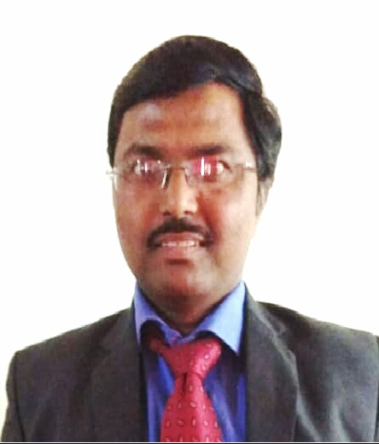
Institute Name | PDEA`s Institute of Technical Education Research and Management, Akurdi, Pune.
Designation | Assistant Professor
Department | MBA
Area of Specialization | Financial Management
Date of Joining the  Institute | 16/08/2010
Qualifications with Class/Grade | UG  B. Com | Firstclass | PG  M.Com  MMS  PGDBM  M.Phil. | First Class  First Class  Distinction  A grade | Others  SET  (Commerce)  GDC&A | FirstClass
Total Experience in  Years | Teaching | 13 Years | Industry | 0 Yrs
Paper Published | International | 05 | National | 03 | State | 01
Books Published | NA

